BMED 4739/6739 - Group 4 Fall 2024  
**Members:** Hendrik Carius, Sofia Fraija, Michael Doyle, Paloma Santiago

**Problem Statement:** Develop 4-DoF robot manipulator, and control the robot tip to follow a pre-defined trajectory, such as a square, triangle, circle, pentagram etc.

**Mechanical Design:**

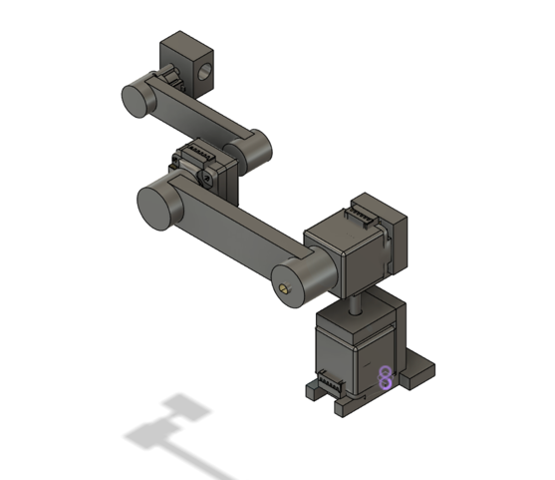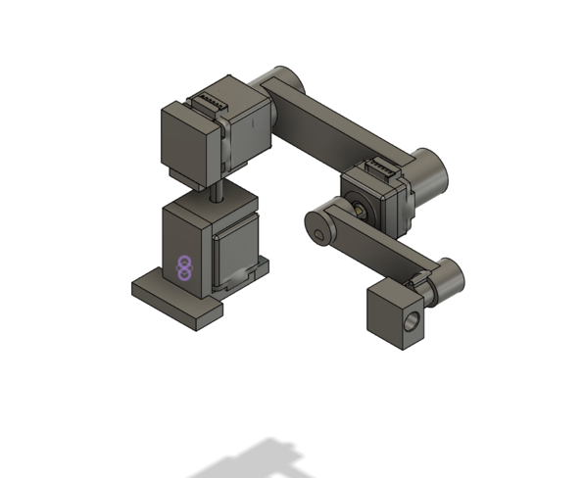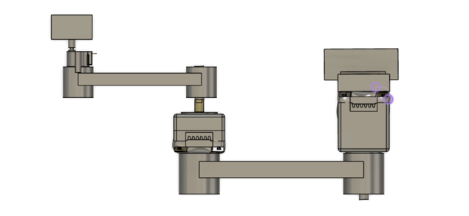

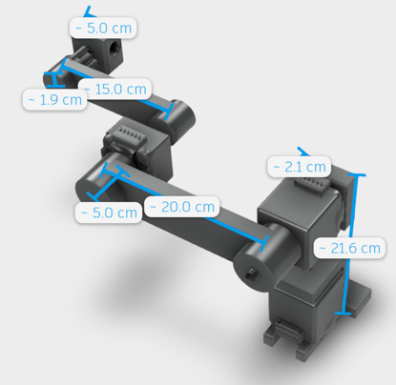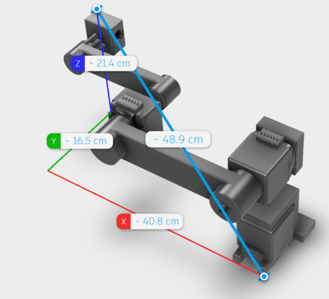

**Electrical Design:** The robot we are building will have the same motor connections, similar to Lab 1, as we will be using the same motors (Nema 17).

**Bill of Materials:**

|  |  |  |  |  |
| --- | --- | --- | --- | --- |
| **Description** | **Quantity** | **Website** | **Price** | **Price Total** |
| Stepper Driver Shield | 1 | [Amazon](https://www.amazon.com/Haosie-Extension-Stepper-Engraver-Printer/dp/B0C6X9VVKM/ref=sr_1_4?dib=eyJ2IjoiMSJ9.K1jXbR39V9ka6bqXHkyQiOezPjQCYK-nhZpNzfdUCYJtaTbNPlSc-KRfNdCDxWQTzgdPyW0J9dQNliZ-lPc16KsVWHPPoybNVtCtyR8yCTIrz_vRPO3MYkYWYvgBP5y22kCTODckQDPEVEVHRhNFptzgnpvWjDiaBL57cg9BnMaDvDtuz_Gcg8Ws1T8P27zq247tgFzIBB42_BpKax_W3RfBH_KQkWu7Ye_MPnPK5uM.TDxnYdIG4TbMrIlQU5w0k5x8D5WDKNgd5Kh9fimsB68&dib_tag=se&keywords=arduino+stepper+motor+shield&qid=1726062478&sr=8-4) | $ 9.99 | $ 9.99 |
| 12V 10A Power Supply | 1 | [Amazon](https://www.amazon.com/Facmogu-Converter-100V-240V-Transformer-5-5x2-5mm/dp/B087LY94T6/ref=sr_1_3?crid=ED1KVMRHTPUZ&dib=eyJ2IjoiMSJ9.3TIj8BvjI8kmHpyLmug4ck-8vlFIcqeE3yN9pTdBPSpIbsRKeh4mGeks2HoFIVbC9-33KBP5JUkLt08vnHAFZy0WaDCAGBg3S7PnmQIW2ZxL9la0XgC1ck5SeXVfjBtLpozMxHMf4wRR1wCLrj9iWg3INPxpQrUS2l3A3QWZV71udquuon327tmSBWRPL0zwV5UwmFx0w7662GVPF5b43AQUeCUcb3HNsidOHooiuCE.PTJYJHKDuaSznlCb00Q4FwO3VeRk3Z2pe9Nd0JfV6Nc&dib_tag=se&keywords=12v+10a+power+supply&qid=1726063272&sprefix=12v+10a+power+supply%2Caps%2C121&sr=8-3) | $ 19.99 | $ 19.99 |
| Power Jack Connector (5.5 x 2.5) | 1 | [Amazon](https://www.amazon.com/Socket-Threaded-Connector-Adapter-3-94Ich/dp/B07QLZ9VWL/ref=sr_1_9?crid=3JLWGPGCWHHOW&dib=eyJ2IjoiMSJ9.-pkyu7VTfrq5qPsn85KgJkAdQOiYiExBNPBBaFeX1WmpamfmUaCDaPL6GYzXviQBn-gzTfo89pmLO83Xpz_FWo9526t7T23wjfAtAJe4-PDJ0BeOH9zoW629zgsl2tci5pJHISvrS-dOtHBKCqfFW6hb0jX8fAHxBDt5nMwABdoaohab_ZVkCrBtS7e5W5-gYL0guX_fuLMijOM1R38FueIUNHQ2Xe68FSPH_ib0vVU.wWSosYYypdi0mn_kvIrg-eShQbtYNqLMDQwpC_hTuQ8&dib_tag=se&keywords=power%2Bsupply%2Bconnector%2B5.5%2Bx%2B2.5%2Bfemale&qid=1726064493&sprefix=power%2Bsupply%2Bconnector%2B5.5%2Bx%2B2.5%2Bfemal%2Caps%2C403&sr=8-9&th=1) | $ 9.99 | $ 9.99 |
| XT 60 Connector | 1 | [Amazon](https://www.amazon.com/Female-Bullet-Connectors-Shrink-Battery/dp/B07233RVL6/ref=sr_1_5?crid=1LNOGP614VTRW&dib=eyJ2IjoiMSJ9.mIU4ivQVeaoM8XcQeU8PwPwV7kWcVaDFzfNfaRD1b8nVmZvagHoPL8han7wJpS9tplUHDbSAT-9HsWrFPXfxoS5uxx4AaB9TH-hhzUrOaW-kCPhN_OROojHFmWcS54IMBSICUDEFZ4ofaG4i5PmfnCwECRbz2jnRvjJXzd59tYbv9zX1b315j_N-pYuPzPvk4R1Mjgag6M60Rj78OsHOrxuBriid61BuMpb9NsfYGSFiH5Zema-omDz1SRFNRIJyIvclPFzYTPs5FvKlr9iM4Ijc97UvshaxQg5tRc-0wh0.9BX8_8X5azaan9StjUhplYOvM5agAjJNg9tJs_JHBXY&dib_tag=se&keywords=xt60&qid=1726244208&s=industrial&sprefix=XT%2Cindustrial%2C126&sr=1-5) | $ 7.99 | $ 7.99 |
| Limit Switch | 1 | [Amazon](https://www.amazon.com/HiLetgo-KW12-3-Roller-Switch-Normally/dp/B07X142VGC/ref=sr_1_12?crid=265Z2YFOF82SO&dib=eyJ2IjoiMSJ9.qufhOh7zKiUIgxkB270VHPl7rC1oNwfI7-GCWJPU9rWu5Q7ZwUdd0DaBoswpXU6Nf3Vned3T_1dIRT0fJDXVLir4AK-ACIhe__qjDbsFtdiYATsPijaj2ia9j6WfsmsUOog5MxJIHSAY2PyCCQ9BxNOEIDdft_eD-XnCh59z2t68AZywRdkuI1_NiyrpPfM-WzRxObGJhcL0c6H3Zd-pp5s9iUAvF4kVPjglfIblQfs.l6SSgvy7Tgc2fvJIwTTUEmat4Sl8VdzX1ZAttTjfi7o&dib_tag=se&keywords=end+stop+arduino&qid=1726065714&sprefix=end+stop+arduino%2Caps%2C877&sr=8-12) | $ 5.99 | $ 5.99 |
| (Emergency) Button | 1 | [Amazon](https://www.amazon.com/Baomain-Emergency-Switch-Button-Weatherproof/dp/B00NTT91Y0/ref=sr_1_5?crid=1T1KQOMYRONRP&dib=eyJ2IjoiMSJ9.tR96YJ6TJT95oZQULBr1UqeQo50WLL2AtRs1HBzf4VzkOKmWCHt6R6A83DdvqlQFAN4P3FVaqgFXjamV5N1UuOcxYswmWjakksauda25Os-J8mlpf9KnSNAQI4Qr8NxA9OHyeqoe0KC_jp3eY8ialT-IArxTnqSj2PQ8JHQ0z_eXFSng64kxDYlO9bvyHKSZFrrc_UOjM38v0BOINlhF4LVRTUZe2kHshbEUo3AWxRs.PtEhRiH8j-r20T-hiTBhH9zWkGMik4WyMQK3rgj8oXc&dib_tag=se&keywords=Emergency+button&qid=1726242677&sprefix=emergency+button%2Caps%2C151&sr=8-5) | $ 9.99 | $ 9.99 |
| Cable ties | 1 | [Amazon](https://www.amazon.com/HAVE-ME-TD-Cable-Ties/dp/B08TVLYB3Q/ref=sr_1_4?crid=33NWQQY40Q0VF&dib=eyJ2IjoiMSJ9.8X8UYFTZg2-fC4c9eC2sSNcJBilvEspqtQNGbaW-cvQT3AQpv3iVvv0GcAbWjyhMsUpZ5DSgmXsMB11rrmGVi2xSZlhrCL3xo3qKwU3uhoqJerzV6YvD7HwDRVmGGG6Wd4K_Q0XDZeXZ1bbWfJrf26AXAV6DjYx9SGOKtJrCuCd_Xm_oxKqEtQXo8tlUBr_HE84quGQBEHMbB483bV7TDEioZT9ZohUD78H2_-QDcJc.WOunMyZd2XvP6wE0tTA_9nsl9gzDEOwiEjQFtDL2nI8&dib_tag=se&keywords=cable+ties&qid=1726163759&sprefix=cable+t%2Caps%2C107&sr=8-4) | $ 5.99 | $ 5.99 |
| Caliper | 2 | [Amazon](https://www.amazon.com/Measuring-Stainless-Micrometer-Fraction-Household/dp/B08Y8M54M9/ref=sr_1_6?crid=3FLBEOIINA850&amp=undefined&dib=eyJ2IjoiMSJ9.L7iRfljm1FWfp3fTrs43I12ki4xYJoUu3gT36eUNEF29QYEqYlJjGZLWJTItzcX3zJ85j6FXKzqXpW-iDAW64xlkPRwtb3ZK5spHA_4OILPXShsfjSDlK-y7wtFRpDg97-KmjTm4TTRyd-QeBTuogHVnXl5Y852AVLa0NCifaeWK7hWY5u8Z3_-k6jKkqWLCgdAznTuVX3jLoNofRSRTu8YRrlDSWDueHUeOvzISYdk.DSZsB3sH3UChPdnq3EmOAbTBbPHtjqDQ1DfK6mQHtFA&dib_tag=se&keywords=Caliber&qid=1726163862&sprefix=calibe%2Caps%2C108&sr=8-6&th=1) | $ 19.98 | $ 39.96 |
| PVC tubes - rectangular | 5 | [Amazon](https://www.amazon.com/USA-SEALING-BULK-RPT-PVC-13-Rectangular-Outside/dp/B08ZLRWYYL/ref=sr_1_2?crid=3CRH9151O6NXG&dib=eyJ2IjoiMSJ9.cT1F4_AjZXg8VPFfbZTE7GF-ebdfB4xbLInnhwMkHZdWiFSF6Bbh3dTSnknSQotBQuwS0EPoyAz8m75rf_vhJJerK2zqeP2dFne9wSOJw0fBKV5tD8r9G0oaN4xqZwji7wmq0K2Eg6M_qr2x2HHU7iw7Xz_k2J2xpjyG4hTlaag2NGIl_Crf9Ot5gGG0eK57jAQidnxiidE9KbFFuZq6iUHUjgVaCdcjw-4A926htAc.rgkIlUb4uFxpT7WKi8ChhWaPGehGiJreJ5-InpDd5pM&dib_tag=se&keywords=pvc+tube+rectangular&qid=1726612265&sprefix=pvc+tube+rectangular%2Caps%2C107&sr=8-2) | $ 8.97 | $ 44.85 |
| Box (10.4 x 7.2 x 3.7) | 1 | [Amazon](https://www.amazon.com/Zulkit-Dustproof-Waterproof-Universal-Electrical/dp/B0CL785L5Y?th=1) | $ 19.99 | $ 19.99 |
| Ball bearing 6005 | 1 | [Amazon](https://www.amazon.com/XiKe-6005-2RSx4Pcs-Double-Pre-Lubricated-Bearings/dp/B07CTRNLQ4/ref=sr_1_11?crid=2G185U792LHLP&dib=eyJ2IjoiMSJ9.0vU_OXIzsaevQsAJavtJbo4ZlX2m3Z5r9eUo0Sl5NUrPwZ5BBcUd1lIMwBgfRC84GFqTUbJMtHRRfFmJnCLFm4RAmajQS7vZ4vPTS4UXVh_JQHw1cqC9YiXf2Uk0wXUXc1fKNgevv9boRP6ybo2Lu7dJKsSOpEcq1kSbpF_hGyei1iuhfHphTTLLY-0pcKe_swZzkfb7gnaAWFv6o2rRKE3M8puQL3CYjKPQgOsrW1M.gVHlXlwBKmqIlCpzClWPS5vNg5qpu1vepKHR_f2ZNt8&dib_tag=se&keywords=ball%2Bbearing%2B6005&qid=1726439253&sprefix=ball%2Bbearing%2B6005%2Caps%2C565&sr=8-11&th=1) | $ 10.99 | $ 10.99 |
| Longer Arduino cable | 1 | [Amazon](https://www.amazon.com/Amazon-Basics-External-Gold-Plated-Connectors/dp/B00NH11KIK/ref=sr_1_2?crid=1W2SYFVFTXY07&dib=eyJ2IjoiMSJ9.MDkCE2bJvbP-kOHt0Xuog1DXd0fkUWNIGIPVdySmOxaEBnZumKgXO_7ssIGULY820oW25Ej0cHBxSDBkrRreyclQ6i3h4CfAKYll3hgEAVA22mqFRQaydczdh9SdDCgnQNK3X0eWDSmKS0KtsEU3Pw0CgcvwTRA5eKFvLkCmHq7zN_uflBcRqUgeJn4q7hyg843lmSGzmMjBOX9a2I0cJx55PbAIcsVj1S4_xAklP66wsj0dcp_9CcPjjblyYVTWjX0luEt1B37J6WMRyLnh1FT_2Jtklq_N8DTCzlKLE0Q.MEBDk8Lf3T6nUiNx_co1qhfKMXcR6M9lhgt4ByuqQM8&dib_tag=se&keywords=usb%2B2%2C0%2Bcable%2Blonger&qid=1726244584&s=industrial&sprefix=usb%2B2%2C0%2Bcable%2Blonger%2Cindustrial%2C105&sr=1-2&th=1) | $ 6.49 | $ 6.49 |
| Hot Glue Gun | 1 | [Amazon](https://www.amazon.com/Sticks-Melting-Carrying-School-Repairs/dp/B08H56Y4ZF/ref=sr_1_16?crid=3KZI97PM7USPY&dib=eyJ2IjoiMSJ9.4jFypAeCytQm0Tr2oZQ128LY09dC71AEZOC3cqQPY6E2T1uxppktpJ0HZhR6TICdvw4C66VF9AI6AUOvRP3mQ2R5Z4-zI9L4RDPCtPgzzpnWVJyrxVQuQ8rhUKdm7AaivY2ynleU78mkKcFITIi6lgdPWBQg3aNecGQSb5JtN9kLuJplVr24dMrpG2nKImF7ozhBV6z2QSkyJvV_1Fn9PncwCLYmOu1Q2ir_fLmFLvT2hiMzZNMkEKs8deuYurcSNbqkcoEFaQi_VDH-Rr4ZQ7JJOB_3Xh8Aptji77UcVU4.M2JqUgnm99_wyKvwkiPUuCQKVhRgCT9hoHTrBxHcmls&dib_tag=se&keywords=hot+glue&qid=1726519794&s=industrial&sprefix=hot+glue%2Cindustrial%2C117&sr=1-16) | $ 9.99 | $ 9.99 |
| 4 pole wire (18AWG-4C, 10 feet) | 1 | [Amazon](https://www.amazon.com/Conductor-Electrical-Oxygen-Free-Residential-4AWG-10FT/dp/B0C6TFBWDM/ref=sr_1_9?crid=2OIJ6BM76GDVF&dib=eyJ2IjoiMSJ9.x8XyTX_WjBB74z2o_RS3wdtcLFn5oLJUIRAC72cidi_FJrbhaOuNHIzEyc6wkUuejkjsV5PyNUFZMqKTchhTEQ_MikCmo8Ic_ZsgE-3PuOmMRFqE0HQDZwVyMqd_PK7b--Hxj9riHB4-4KJ7GhH12H3Aa3SFccxUfp8M0kAl3sjJpGrHOMw1x6gnUSteY0OQ92J0mTFr-eyJ73klvFZnjfZ0r1Qb98T7F6NHqML7poXwYdr4Yt7MpwQS3r_yuzoWk27plzVA0q9QmYBnImwlly5ciLlujH7aowKVm-yA53E.QE9m686FB4Lolng5mUPZuxJ6oAS82qesWdqR312zB4I&dib_tag=se&keywords=4%2Bpole%2Bwire&qid=1726520113&sprefix=4%2Bpole%2Bwire%2Caps%2C133&sr=8-9&th=1) | $ 9.99 | $ 9.99 |
| 4 pin connectors | 1 | [Amazon](https://www.amazon.com/Molex-Connector-Matched-4-Circuits-18-24/dp/B0753VW1B4/ref=sr_1_1?crid=3JHSTTF3UL60C&dib=eyJ2IjoiMSJ9.DBQy6YKYyDseuqkDuEkLbDbb0J1Yzj78CuwhjOrUXwIIjLs4g1SJgF8gRMYDAqiSuuLF4eScZgKiZQAZBHSya3Cuf-bu2c7ikCTc6SmtIrG43glYyKXmFvBIzMUl9YMTmnYKDZaNr8J2d3EjZbUpvtGy7TOTkvbnuEp5IOclVgv4ndeeuL_raFJRXMJnVmX9t0ERhytuBMRYxKd_eWR-x5E4XMEprFvjPeEiYPjfv7I.Ya7T1yu8QL6aUatBQbchbmEqlE3_EAK8-mxnGaGcodk&dib_tag=se&keywords=molex+4+pin&qid=1726522150&sr=8-1) | $ 5.20 | $ 5.20 |